*A Project Report on*

## ***BLOCKCHAIN BASED CROWDFUNDING PLATFORM***

*Submitted in Partial Fulfillment of the Requirements For the award of the degree* *Master of Computer Applications.*

***SUBMITTED BY***

***AMOGH SARAVAGOL 23P01165***



## *PRESIDENCY COLLEGE*

*Kempapura, Hebbal, Bengaluru – 24*

***Re-accredited by NAAC with ‘A+’ Grade***

*DEPARTMENT OF COMPUTER APPLICATIONS*

**

***CERTIFICATE***

*This is to certify that* ***Amogh Saravagol*** *with Register No.* ***23P01165*** *has satisfactorily completed the fourth semester MCA Project titled* ***“BLOCKCHAIN BASED CROWDFUNDING PLATFORM”,*** *as a partial fulfillment of the requirements for the award of the Degree in* ***MASTER OF COMPUTER APPLICATION****, awarded by* ***BENGALURU CITY UNIVERSITY*** *during the Academic Year* ***2023-2025.***

***Project Guide: Ms. Uma Mageshwari*** ***Head of Department***

*(Department of Computer Application)*

***Examiners Reg No: - 23P01165***

*1.--------------------------------* ***Examination Center: Presidency college***

*2.--------------------------------* ***Date of the exam: --------------***

# ***Declaration***

*The project titled* ***“BLOCKCHAIN BASED CROWDFUNDING PLATFORM”*** *developed by me in the partial fulfillment for the award of Master of Computer Application. It is a systematic work carried by us under the guidance of*

***Ms. Uma****, Assistant professor, Department of Computer Applications.*

*I, declare that this same project has not been submitted to any degree or diploma to the Bengaluru City University or any other Universities.*

*Name of the student: - Amogh Saravagol*

*Date: _______________*

*Signature:*

# ***Acknowledgement***

*The development of software is generally bit complex and time-consuming task. The goal of developing the project* ***“BLOCKCHAIN BASED CROWDFUNDING PLATFORM”*** *could not be archived without the encouragements of kindly helpful and supportive people. Here by we convey our sincere thanks for all of them.*

*I take this opportunity to express my gratitude to people who had been instrumental in the successful completion of this project.*

*I am thankful to our management trustee for providing us an opportunity to work and complete the project successfully.*

*I wish to express my thanks to our* ***Principal Dr. Pradeep Kumar Shinde*** *for her support to the project work. I would like to acknowledge my gratitude to our HOD of Master of Computer Applications.* ***Dr. Alli*** *for her encouragement and support. Without their encouragement and guidance this project would not have materialized.*

*The guidance and support received from our Internal Guide* ***Ms. Uma****, who*

*contributed to this project, was vital for the success of the project. We are grateful for his constant support and help.*

***Abstract***

*Blockchain expertise, known for its decentralized, transparent, and secure solutions, has transformed various industries. This paper explores the significant potential of integrating blockchain into crowdfunding, the repetition of raising capital through contributions from friends, family, customers, and investors. We propose a blockchain-based crowdfunding platform designed to enhance accessibility, efficiency, and trust. The platform leverages smart contracts to automate the funding process, ensuring that funds are only released upon meeting predefined conditions, thus reducing fraud and increasing transaction security. Blockchain’s inherent characteristics guarantee the immutability and transparency of all transactions, providing a verifiable audit trail. Additionally, the platform incorporates tokenization, allowing contributors to receive digital tokens in exchange for their aids, which can be traded or utilized within the ecosystem.*

***Keywords: Blockchain, Crowdfunding, Smart Contracts, Decentralization, Tokenization, Transparency, Security, Efficiency, Regulatory Compliance.***

|  |  |
| --- | --- |
| ***CONTENTS*** | ***Page.no*** |
| *1. INTRODUCTION* | *1* |
| *1.1 TYPES OF CROWDFUNDING* | *2* |
| *1.2 PROBLEM STATEMENT* | *3* |
| *1.3 OBJECTIVES OF CROWDFUNDING* | *3* |
| *1.4 SCOPE OF CROWDFUNDING* | *4-5* |
| 1. *2. LITERATURE SURVEY*   *2.1 EXISTING AND PROPOSED SYSTEM* | *13-17* |
| *2.2 FEASIBILITY STUDY* | *17* |
| *2.3 TOOLS AND TECHNOLOGIES USED* | *18-19* |
| 1. *3. SOFTWARE REQUIREMENT SPECIFICATION*   *3.1 USERS* | *20-21* |
| *3.2 FUNCTIONAL REQUIREMENTS* | *21-22* |
| *3.3 NON-FUNCTIONAL REQUIREMENTS* | *22-23* |
| *4. SYSTEM DESIGN (High level or architectural design)*  *4.1 SYSTEM PERSPECTIVE* | *24* |
| *4.2 CONTEXT DIAGRAM*  *4.3 TEST CASE*  *444 4.4 USE CASE DIAGRAM* | *24-25* |
| *5. IMPLEMENTATION (CODE SNIPPETS)* | *26-28* |
| *5.1 SCREENSHOTS* | *29-31* |
| *6. CONCLUSION* | *32* |
| *7. FUTURE ENHANCEMENT* | *33-34*  *-* |
| *8. BIBOLOGRAPHY* | *35- -36* |

***Chapter 1 Introduction***

## ***1.1 Background of the Study***

*Traditional crowdfunding platforms face multiple challenges that undermine trust, efficiency, and user satisfaction. One of the most significant limitations is the lack of transparency regarding how collected funds are managed after a campaign ends. Contributors are often left in the dark, with no reliable way to track whether funds are being used for the intended purpose or whether the project is progressing as promised. This uncertainty not only discourages potential backers but also weakens accountability on the part of campaigners.*

*Another critical concern lies in the centralized nature of existing crowdfunding platforms. Since all control rests in the hands of a single authority or intermediary, the system becomes susceptible to fraud, manipulation, censorship, and single points of failure. For instance, server crashes, technical malfunctions, or targeted cyberattacks can compromise the platform’s availability and security. Moreover, centralized entities have unilateral power over campaign approvals, fund disbursement, and dispute resolutions—leaving little room for contributor protection.*

*High platform transaction and service fees further reduce the effectiveness of crowdfunding. A significant portion of funds raised is often withheld by intermediaries as operational costs, which reduces the amount actually available to campaigners. In addition, many platforms enforce lengthy payment withholding or review processes, delaying fund access and creating financial strain for project creators who rely on timely disbursement to initiate their work. Contributors also face uncertainty since refunds or reimbursements in case of failed or fraudulent projects depend entirely on the platform’s internal policies, which may not always favor users.*

*These shortcomings highlight the need for a more trustworthy, efficient, and secure crowdfunding ecosystem. Blockchain technology presents a promising solution to these issues. By leveraging the properties of decentralization, immutability, and programmability, blockchain-based crowdfunding platforms can ensure greater accountability and transparency. Smart contracts can automate fund management, ensuring that contributions are only released when predefined conditions—such as project milestones or deliverables—are met. This reduces the risk of misuse and guarantees that contributors have more control over their funds.*

*Additionally, blockchain removes the reliance on a single centralized authority, minimizing risks of censorship, manipulation, or operational downtime. The use of immutable ledgers enables transparent tracking of every transaction, giving contributors real-time visibility into project progress and fund utilization. Furthermore, by reducing or eliminating intermediaries, blockchain-based platforms can significantly lower transaction costs, ensuring that more funds directly reach project creators.*

*Ultimately, a blockchain-powered crowdfunding system can restore trust, enhance transparency, and improve efficiency, paving the way for a more reliable and inclusive funding environment. Such a solution empowers contributors with confidence in how their funds are used, while campaigners benefit from fairer, faster, and more secure access to financial resources.*

## ***1.2 Problem Statement***

*Traditional crowdfunding platforms, while revolutionary in enabling individuals and organizations to raise funds for creative, social, or entrepreneurial ventures, face several inherent limitations that undermine their effectiveness and reliability.*

*One of the most pressing issues is the lack of transparency in fund utilization. Once the contributions are collected, contributors have little or no visibility into how their money is being spent or whether the promised milestones are being achieved. This lack of accountability often creates skepticism among backers and reduces trust in the overall system.*

*In addition, the centralized architecture of these platforms introduces several risks and inefficiencies. A single authority or organization controls fund collection, approval, and disbursement, making the system vulnerable to fraud, manipulation, biased decisions, and censorship. Centralized servers also create single points of failure, where downtime, technical glitches, or cyberattacks can disrupt services and compromise user data.*

*Another significant problem lies in the financial inefficiencies associated with traditional platforms. Most platforms impose high service charges and transaction fees, significantly reducing the net funds available to campaigners. Moreover, internal verification and compliance checks often result in delays in fund disbursement, creating financial bottlenecks for project initiators. Contributors, on the other hand, face the risk of losing their money if a campaign fails or is abandoned, since refunds are not always guaranteed or timely.*

*These limitations collectively reduce user confidence, hinder the growth of genuine projects, and leave the crowdfunding ecosystem vulnerable to misuse.*

*A blockchain-based solution has the potential to overcome these challenges by providing a decentralized, transparent, and secure alternative. Through immutable ledgers, every transaction can be permanently recorded and made visible to all stakeholders, ensuring that contributors can track the use of funds in real time. The use of smart contracts allows for automated and conditional fund disbursement, where contributions are released only upon the successful completion of predefined milestones. This eliminates the risk of mismanagement and ensures fairness for both contributors and campaigners.*

*Furthermore, decentralization removes reliance on a single controlling entity, thereby minimizing risks of fraud, censorship, and operational downtime. By reducing intermediaries, blockchain-based platforms can also lower transaction costs and accelerate payment processes, ensuring that campaigners receive funds more efficiently while contributors benefit from increased security and accountability.*

*In summary, the key problems of traditional crowdfunding platforms—lack of transparency, centralized risks, high costs, and delayed or insecure fund management—necessitate the development of a more reliable, efficient, and trust-enhancing crowdfunding ecosystem. Blockchain technology provides the foundation for such a solution, enabling fairness, operational resilience, and a new level of trust between contributors and campaigners.*

***1.3 Objectives of Crowdfunding****:*

1. ***Decentralization:***

*Utilizing blockchain knowledge allows crowdfunding platforms to operate without mediators such as banks or traditional economic institutions. This decentralized approach enhances transparency, lowers costs, and reduces the risk of censorship or manipulation.*

1. ***Global Access:***

*Blockchain-based crowdfunding enables participation from a worldwide audience. Anyone with internet access and cryptocurrency can contribute to projects, regardless of their location or financial status. This broadens the reach of fundraising campaigns and allows projects to garner support from a diverse group of contributors.*

1. ***Transparency and Security:***

*Blockchain technology ensures transparent and immutable transaction records. All fundraising activities, including contributions and disbursements, are documented on the blockchain, providing accountability and transparency. The use of cryptographic methods enhances transaction safety and reduces the risk of fraud or tampering.*

1. ***Smart Contracts:***

*Blockchain-based crowdfunding often employs smart agreements, which are self-executing contracts with terms straight written into code. Smart contracts automate the fundraising process, releasing funds to project creators based on predefined conditions or milestones. This minimizes the need of faith between parties and decreases the risk of fund mismanagement or misuse.*

1. ***Access to Capital:***

*Blockchain-based crowdfunding offers an alternative capital source for projects that may struggle to obtain traditional financing, such as venture capital or bank loans. Entrepreneurs, startups, and innovators can raise capitals directly from the community, bypassing traditional gatekeepers and regulatory obstacles associated with conventional fundraising methods.*

***1.4 Scope of Crowdfunding:***

1. ***Startup Funding:***

*Blockchain-based crowdfunding platforms offer startups and earlystage companies an alternative means of raising capital. Entrepreneurs can issue tokens or digital properties over initial coin offerings (ICOs) or token sales, allowing them to bypass traditional fundraising methods such as venture capital or bank loans.*

1. ***Decentralized Finance (DeFi):***

*In the decentralized finance (DeFi) ecosystem, crowdfunding is essential. DeFi platforms use blockchain knowledge to create financial products and services without intermediaries. These platforms utilize crowdfunding mechanisms like liquidity pools, lending protocols, and decentralized exchanges (DEXs) to enable peer-to-peer lending, borrowing, and trading of digital assets.*

1. ***Real Estate Investment:***

*Blockchain-based crowdfunding facilitates fractional ownership of real estate assets, allowing depositors to buy and trade tokens representing fractional shares of properties. This provides access to real estate markets previously unavailable to individual investors, offering benefits of liquidity and diversification.*

1. ***Tokenization of Assets:***

*Crowdfunding platforms can tokenize various assets, including artwork, intellectual property, commodities, and collectibles. By converting real-world assets into digital tokens on a blockchain, these platforms enable fractional ownership, enhance liquidity, and simplify the transfer of ownership.*

1. ***Social Impact Projects:***

*Blockchain-based crowdfunding can support social impact projects and charitable initiatives by offering a transparent and accountable fundraising mechanism. Donors can monitor fund allocation in real-time, ensuring their charities are effectively used for social causes and humanitarian efforts.*

1. ***Reward-Based Crowdfunding:***

*Blockchain technology can improve traditional reward-based crowdfunding models by adding transparency, security, and automation through smart contracts. Contributors can receive digital tokens or rewards issued on the blockchain in return for their contributions, ensuring fair and transparent distribution of incentives.*

***1.5 Organization of the Report***

* ***Chapter 2: Literature Review*** *– Reviews existing research and solutions related to crowdfunding platforms and blockchain technology.*
* ***Chapter 3: System Analysis and Design*** *– Details the system requirements, use case diagrams, and architecture of the proposed system.*
* ***Chapter 4: System Implementation*** *– Discusses the technologies used, the development environment, and the implementation process.*
* ***Chapter 5: Testing and Evaluation*** *– Describes the testing methods, test cases, and evaluation of system performance.*
* ***Chapter 6: Conclusion and Future Work*** *– Summarizes the project findings, contributions, limitations, and suggests areas for future improvement.*

# ***Chapter 2 Literature Review***

### ***2.1 Existing Systems***

*Below are several existing applications, studies, and platforms in the space of blockchain crowdfunding, what they do well, and their limitations.*

|  |  |  |  |
| --- | --- | --- | --- |
| ***System / Study*** | ***What it does / Features*** | ***Strengths*** | ***Weaknesses / Limitations*** |
| Crowdfunding Using Blockchain Technology: A Review *(Gupta et al., JSS Academy) (*[*iet.adsrs.net*](https://iet.adsrs.net/index.php/iet/article/view/9?utm_source=chatgpt.com)*)* | *Survey of how blockchain can address trust, transparency and other issues in crowdfunding. Discusses smart contracts, donor reluctance due to fraud, etc. (*[*iet.adsrs.net*](https://iet.adsrs.net/index.php/iet/article/view/9?utm_source=chatgpt.com)*)* | *Good overview of the problems in traditional systems; identifies blockchain properties that can help. Helps pin down which parts of the current systems are weak.* | *Largely conceptual; not many implementation details; doesn’t deeply handle regulatory / performance / cost trade‐offs; doesn’t compare many blockchain platforms in practice.* |
| Efficient Use of Blockchain for Crowdfunding Platform *(2023) (*[*ACM Digital Library*](https://dl.acm.org/doi/abs/10.1145/3607947.3607966?utm_source=chatgpt.com)*)* | *Proposes a DApp (Decentralized Application) model; uses smart contracts and blockchain to make crowdfunding more secure and transparent; emphasizes cost saving and risk reduction. (*[*ACM Digital Library*](https://dl.acm.org/doi/abs/10.1145/3607947.3607966?utm_source=chatgpt.com)*)* | *Shows a working model; emphasizes measurable benefits like cost or speed; gives architecture or design considerations; moves beyond theory.* | *May be limited in scale; may not have addressed volatility / compliance / KYC; performance and usability issues may be less explored; probably prototype rather than full real‐world deployment.* |
| Blockchain Based Crowdfunding for Education *(Islam et al.) (*[*IJRASET*](https://www.ijraset.com/research-paper/blockchain-based-crowdfunding-for-education?utm_source=chatgpt.com)*)* | *Application of blockchain crowdfunding in the education domain—helping students, small schools, educational projects. Focuses on transparency, accountability; uses Web3 tech. (*[*IJRASET*](https://www.ijraset.com/research-paper/blockchain-based-crowdfunding-for-education?utm_source=chatgpt.com)*)* | *Good specific use‐case; addresses domain‐specific concerns (education); likely has user interface / domain requirements more fleshed out; shows user benefit.* | *Might be limited to certain geographic regions; may not address financial regulation or tokenization features; scalability or generalization to non‐educational crowdfunding not shown.* |
| Crowdfunding Platform using Smart Contracts *(Sulekh, Katiyar, Trivedi) (*[*IJISRT*](https://ijisrt.com/crowdfunding-platform-using-smart-contracts?utm_source=chatgpt.com)*)* | *Implements a blockchain‐based crowdfunding platform using Ethereum smart contracts. Looks at funds tracking, campaign management, incentives. (*[*IJISRT*](https://ijisrt.com/crowdfunding-platform-using-smart-contracts?utm_source=chatgpt.com)*)* | *Practical architecture; shows how smart contracts can help; addresses trust and automated execution.* | *Ethereum gas costs, transaction latency, user onboarding issues; regulatory / KYC / fiat integration likely not deeply handled; perhaps no discussion of stablecoins or volatility.* |
| Blockchain and Stablecoin Integration for Crowdfunding *(Ünsal, 2025) (*[*arXiv*](https://arxiv.org/abs/2501.11145?utm_source=chatgpt.com)*)* | *Proposes integrating* ***stablecoins*** *to counter cryptocurrency volatility; adds compliance (KYC / AML); uses tokenization; gives framework to improve security, liquidity, efficiency. (*[*arXiv*](https://arxiv.org/abs/2501.11145?utm_source=chatgpt.com)*)* | *Very relevant for solving real problems like volatility; includes regulatory concerns; adds liquidity via secondary trading; more mature design.* | *Possible complexity; legal challenges in different jurisdictions; stablecoins bring their own regulatory scrutiny; implementation cost; user complexity; not clear how well the framework has been prototyped or tested in large scale.* |
| Evaluation of Blockchain‑Based Crowdfunding Campaign Success Factors *(VASMA‑L etc.) (*[*MDPI*](https://www.mdpi.com/2076-3387/13/6/144?utm_source=chatgpt.com)*)* | *Analyzes success factors for blockchain crowdfunding (versus traditional), identifies dimensions such as team size, social network, early investments etc.; focuses on what drives success. (*[*MDPI*](https://www.mdpi.com/2076-3387/13/6/144?utm_source=chatgpt.com)*)* | *Helps in understanding what makes campaigns succeed; empirical basis; helps guide design of platforms (what features to prioritize).* | *Less about platform architecture; doesn’t give implementation; doesn’t always address transparency features, compliance, fund disbursement, fraud prevention in technical depth; may lack geographical/regulatory diversity.* |

### ***2.2 Comparative Study / Related Work***

*Here’s a comparison drawn from the above and related works. The idea is to see how they differ and where there are gaps.*

|  |  |  |  |
| --- | --- | --- | --- |
| ***Feature / Attribute*** | ***Traditional Crowdfunding Platforms (e.g. Kickstarter, GoFundMe)*** | ***Blockchain‑Based Platforms (from literature)*** | ***Your Project (Blockchain-based Crowdfunding Platform) – anticipated improvements*** |
| ***Transparency of funds usage*** | *Weak; backers often rely on project updates; no immutable record; difficult to audit after funding.* | *Many works propose or implement smart contracts, immutable ledgers, public transaction history. E.g., “Crowdfunding Using Blockchain Technology: A Review” or “Crowdfunding Platform using Smart Contracts” show how blockchain can help. (*[*iet.adsrs.net*](https://iet.adsrs.net/index.php/iet/article/view/9?utm_source=chatgpt.com)*)* | *Your project will implement transparent disbursement tied to milestones stored on blockchain; public ledger view; perhaps contributor dashboards.* |
| ***Decentralization / Intermediary removal*** | *Centralized control, platform fees, decisions by platform administrators.* | *Blockchain designs remove or reduce intermediaries; smart contract automates fund release; some designs are DAOs (Decentralized Autonomous Organizations) e.g. LikeStarter. (*[*arXiv*](https://arxiv.org/abs/1905.05560?utm_source=chatgpt.com)*)* | *You can design so that platform fees are minimal, control is transparent, possibly governed by stakeholder votes; automate what was manual.* |
| ***Handling volatility / Stable value*** | *Fiat currency or conventional payment methods; lesser concern about blockchain volatility as cryptocurrencies usually not involved (or if involved, platform handles conversion).* | *The Ünsal framework integrates stablecoins to counter volatility. (*[*arXiv*](https://arxiv.org/abs/2501.11145?utm_source=chatgpt.com)*)* | *Including stablecoin support or mechanisms to convert or protect against crypto volatility would be an improvement.* |
| ***Regulatory / Compliance Features (KYC / AML etc.)*** | *Often traditional platforms have to comply with local laws; sometimes KYC / identity verification required.* | *Some works mention compliance, but many are conceptual or limited to certain jurisdictions; the Ünsal paper is explicit about integrating compliance. (*[*arXiv*](https://arxiv.org/abs/2501.11145?utm_source=chatgpt.com)*)* | *Ensuring your project includes KYC/AML (where needed), considers jurisdictional regulations, and integrates or supports required compliance will make it more robust and acceptable.* |
| ***Success Factor Considerations*** | *Traditional platforms studied in many empirical papers: What campaign characteristics, social network effects etc. lead to success. (*[*SpringerOpen*](https://jfin-swufe.springeropen.com/articles/10.1186/s40854-022-00345-6?utm_source=chatgpt.com)*)* | *Blockchain‑based studies also examine some success factors (team size, early backers, etc.) but often limited scale or limited diversity of campaigns. VASMA‑L analysis etc. (*[*MDPI*](https://www.mdpi.com/2076-3387/13/6/144?utm_source=chatgpt.com)*)* | *You can design your platform to optimize for known success factors—e.g., features that encourage early contributions, high social engagement; include metrics to measure and adapt.* |
| ***Usability, Performance, Scalability*** | *Well‑established; good user experience; usually fast transactions (fiat), well known payment gateways.* | *Blockchain platforms suffer issues: gas fees (Ethereum), transaction delays, user technical knowledge, wallet management. Some works highlight these limitations. (*[*IJISRT*](https://ijisrt.com/crowdfunding-platform-using-smart-contracts?utm_source=chatgpt.com)*)* | *In your project you can choose blockchain platforms with lower fees (Layer 2, sidechains), optimize smart contracts, provide good UX, possibly hide complexity from users.* |
| ***Liquidity / Secondary Markets / Tokenization*** | *Usually reward‑ or donation‑based: contributors get perks, not necessarily tradable value; little secondary trading.* | *Works like the stablecoin integration one mention tokenization and enabling fractional ownership or secondary market trading. (*[*arXiv*](https://arxiv.org/abs/2501.11145?utm_source=chatgpt.com)*)* | *Including tokenization where appropriate can differentiate your platform—e.g., for equity‑style crowdfunding or when contributors expect returns or tradable tokens.* |

### ***2.3 Research Gap***

*From the survey of existing systems and work, here are the gaps or areas where current solutions are lacking — places where your project can contribute/or must address:*

1. ***Volatility and Value Stability*** *Many blockchain crowdfunding models use cryptocurrencies directly, exposing contributors and campaigners to price fluctuation risk. Few existing studies integrate stablecoins or mechanisms to anchor value. Your project can address this by using stable value tokens, or conversion to fiat value, or hybrid models.*
2. ***Regulatory Compliance and KYC/AML Integration*** *Although some frameworks (like Ünsal 2025) consider compliance, many implementations or proposals are silent or shallow on the legal/regulatory side—especially cross‑jurisdiction. Without robust compliance mechanisms, adoption can be limited. Your project should incorporate these elements explicitly.*
3. ***Scalability, Cost & Performance*** *Chain fees (gas), slow transaction confirmations, and cost of smart contract deployment are often high in public blockchains (e.g. Ethereum). Many existing proposals either do not fully solve these or do not consider cheaper alternatives (Layer‑2, side chains etc.). Your project can improve by selecting efficient blockchain environments, optimizing smart contract design, or batching/optimizing transactions.*
4. ***Usability and Non‑Technical Users*** *Many of the blockchain project works assume users understand crypto wallets, gas fees, etc. For mass adoption, non‑technical users need a simple interface; behind‑the‑scenes complexity should be minimized. Projects often lack usability studies. Your project can fill this gap by focusing on UX, onboarding flows, wallet abstractions, etc.*
5. ***Transparent and Enforceable Milestones / Smart Contract‑based Disbursements*** *Some works propose or build smart contract disbursement based on milestones, but many are conceptual; real tracking and verification of milestone delivery remain difficult. Your platform can tie actual deliverables or proof of work to smart contracts for release of funds.*
6. ***Empirical Evaluation / Real‑World Deployment*** *Many studies are prototypes, conceptual models, or small‐scale case studies. There is less work showing long‑term usage, user behavior, security audits, or large campaigns. Your project could include pilot deployment, user feedback, security testing, etc.*
7. ***Tokenization, Liquidity, Secondary Market*** *For crowdfunding models that expect returns or equity, tokenization and secondary market capabilities are still under‑explored. Your project can offer features for fractional ownership, token trading, etc., if legally permissible.*
8. ***Cross‑Chain / Interoperability & Cost of Entry*** *Blockchain ecosystems are fragmented. Projects tied to a single chain may limit reach or have high fees. Not many works address interoperability (allow contributions / assets across chains, or switch chains). Also, high cost of entry (wallets, crypto acquisition) can be a barrier.*

## ***Chapter 3 – System Analysis***

***Introduction***

*The blockchain-based crowdfunding platform is designed to provide a transparent, decentralized, and secure environment for raising and contributing funds. It will primarily support two categories of users: campaign creators and backers. Campaign creators will have the ability to launch new campaigns, define funding goals, specify deadlines, and provide detailed descriptions of their projects, including images and multimedia to engage potential contributors. They will also be able to post updates, share milestones, and communicate directly with their supporters to maintain trust and engagement throughout the campaign lifecycle. Backers, on the other hand, will be able to browse available campaigns through advanced search and filtering options, evaluate project details, and contribute to causes that align with their interests using a variety of cryptocurrencies.*

*The platform’s core strength lies in its integration with blockchain technology and smart contracts. Every campaign creation, donation, and fund disbursement is recorded immutably on the blockchain, ensuring that no data can be tampered with or deleted. Smart contracts automate fund management by enforcing predefined conditions such as funding targets and deadlines. This means that contributions are only released to campaign creators when the specified goal is achieved within the allotted time. If the campaign fails to reach its target, contributors are automatically refunded without requiring manual intervention. This mechanism eliminates the risks associated with misuse of funds and ensures fairness for all stakeholders.*

*To further enhance usability, the platform will include a comprehensive campaign management dashboard for creators, allowing them to monitor contributions, track progress, and interact with backers. For contributors, the system will provide real-time updates on the funding status of campaigns they have supported, as well as a transaction history to ensure complete accountability. In addition, sophisticated search and filter capabilities will enable users to discover campaigns based on categories, popularity, funding status, or keywords, thereby improving accessibility and engagement.*

*Beyond functionality, the platform is being built with a strong emphasis on non-functional requirements such as scalability, performance, and reliability. It will be capable of handling multiple campaigns and a high number of concurrent users without service interruptions. Security will be ensured through wallet-based authentication, encrypted transactions, and thorough smart contract auditing, while transparency is inherently guaranteed through the decentralized ledger. Interoperability with multiple blockchains and support for various cryptocurrencies will make the system globally accessible, while maintainability and modular design will allow for future enhancements such as mobile application support, analytics, and AI-driven recommendations.*

*Overall, this crowdfunding platform aims to transform the way campaigns are funded by combining the efficiency of blockchain technology, the trust of immutability, and the inclusiveness of global cryptocurrency participation. It creates a fairer and more secure ecosystem that not only empowers campaign creators with timely access to funds but also provides backers with confidence that their contributions are being utilized responsibly.*

***3.1 Requirement Analysis***

### ***User Requirements***

*The crowdfunding platform using blockchain will have the following types of users:*

* ***Campaign Creators:***

*Individuals or groups that use the crowdfunding platform to raise donations for various projects or causes are known as campaign creators. Their tasks include planning and managing campaigns, establishing financial targets, communicating campaign progress, and actively connecting with backers to gain support. Campaign creators have the ability to launch new campaigns, manage campaign details, contact directly with backers to answer questions or offer updates, and withdraw funds after their funding goals are fulfilled. This job enables creators to efficiently promote their efforts and manage money donations transparently.*

* ***Backers: Backers:***

*Individuals or companies who participate in the platform's backer program contribute monies to support creator campaigns. Their tasks include viewing available campaigns, contributing to projects that match with their interests or principles, and monitoring the success of campaigns they have supported. Backers can browse and search for campaigns based on specific categories or keywords, make direct contributions to campaigns, and view their contribution history for monitoring reasons. This job enables backers to participate in a range of initiatives, giving to causes they believe in while measuring the impact of their contributions.*

*These user roles are intended to encourage a collaborative and transparent environment in which campaign creators can effectively collect funds and manage projects, and backers may discover worthwhile efforts.*

***System Requirements***

#### **Hardware Requirements**:

* ***Client Side (Users)****:*
  + *Any device (PC, laptop, mobile) with internet access.*
* ***Server Side (Hosting Smart Contracts / Backend)****:*
  + *Cloud-based server (for frontend and API services).*
  + *Ethereum-compatible blockchain network (e.g., Ethereum, Polygon, or BSC testnet/mainnet).*

#### **Software Requirements:**

* ***Frontend****: HTML5, CSS3, JavaScript, React.js or Vue.js.*
* ***Backend****: Node.js / Express.js.*
* ***Smart Contracts****: Solidity (for Ethereum-compatible networks).*
* ***Blockchain Network****: Ethereum / Polygon (testnet for development, mainnet for deployment).*
* ***Database****: MongoDB / IPFS (for storing metadata if needed).*
* ***Wallet Integration****: MetaMask or WalletConnect for crypto transactions.*

***Frontend Technologies:***

* *ReactJS:*

*ReactJS is a leading JavaScript library known for building dynamic and responsive user interfaces. It will play a vital role in the platform by enabling the growth of interactive, single-page applications that facilitate user interactions such as campaign creation and contributions. This ensures a smooth and engaging user experience. Additionally, TailwindCSS will be utilized, a utility-first CSS framework that allows for the rapid creation of custom designs directly in HTML. TailwindCSS will be instrumental in designing a modern, responsive, and consistent user interface with minimal custom CSS, ensuring that the platform is visually appealing and easy to navigate. Together, these technologies will provide a robust and user-friendly environment for the platform's users.*

* *Blockchain Integration*

*MetaMask and Thirdweb facilitate blockchain integration of platform. MetaMask is a commonly used cryptocurrency wallet that permits users to manage digital assets and securely store private keys. It connects user wallets to the platform, assuring secure transactions and contributions while also enabling smooth interaction with blockchain smart contracts. Thirdweb makes it easier to create and deploy blockchain applications by offering user-friendly SDKs, smart contract management tools, and blockchain activity statistics. MetaMask and Thirdweb work together to guarantee the platform's blockchain features are integrated efficiently, securely, and effectively.*

* *MetaMask is a widely-used cryptocurrency wallet that facilitates interaction with Ethereum-based applications. It features a user-friendly interface for managing digital assets and securely storing private keys. MetaMask is essential for connecting user wallets to the platform, enabling secure transactions and contributions. It also facilitates interaction with blockchain smart contracts, ensuring seamless integration with decentralized applications (DApps).*
* *Thirdweb is a development platform designed to simplify the creation and deployment of blockchain applications. It offers user-friendly SDKs for blockchain integration, tools for deploying and managing smart contracts, and analytics and monitoring capabilities for blockchain applications. Thirdweb will play a crucial role by simplifying blockchain functionalities such as smart contract deployment and management. Additionally, it will provide essential development and monitoring tools for on-chain activities, ensuring efficient and effective blockchain integration.*

***3.2 Feasibility Studies***

* ***Technical Feasibility:***

*A variety of elements contribute to the proposed platform's technical feasibility. First, the application will be constructed with ReactJS, a popular and powerful JavaScript toolkit for creating user interfaces. This option assures that the platform is interoperable with any web browser, giving consumers flexibility and accessibility across several devices and operating systems. Second, the platform will require internet access, which is a common requirement for web-based apps to ensure real-time access and updates. Finally, users will require the 'Metamask' browser extension to sign transactions. Metamask is commonly used for communicating with blockchain applications, making it a dependable and safe solution for managing cryptocurrency transactions. Together, these aspects demonstrate that the platform is technically possible and can be implemented with well-established technologies and processes.*

* ***Social Feasibility:***

*Crowdfunding over the years has helped people but has also seen heavy frauds in the name of Crowdfunding. With Betterfund we want to bring transparency to the process of crowdfunding and build trust among people to contribute to all the causes.*

* ***Economic Feasibility:***

*Several significant variables contribute to the proposed platform's high economic feasibility. The Ethereum Blockchain's inherent powerful security features drastically minimize development expenses. This reduces the need for considerable investment in security infrastructure, as the blockchain's built-in processes assure data integrity and transaction security. As a result, the primary expense will be the server costs associated with deploying and maintaining the application. This cost is relatively modest compared to typical centralized platforms that need major investment in security, database management, and payment processing infrastructure. As a result, using the Ethereum Blockchain improves safety but also makes the platform more economically viable by lowering development and operating costs.*

* ***Operational Feasibility:***

*The system is* ***operationally feasible*** *due to its simple, user-friendly web interface and wallet-based authentication. No special training is required for contributors or campaign creators. The use of smart contracts for fund disbursement automates core functions, reducing human intervention and potential error.*

*Additionally, the transparent nature of blockchain will help gain trust and adoption among users who are wary of fraud or fund misuse in traditional crowdfunding platforms.*

## ***3.3 Functional and Non Functional Requirement***

***Functional Requirement***

* ***Campaign Management:***

*Campaign management on the platform provides campaign creators with vital tools for effectively promoting and overseeing their projects. Creators can launch new campaigns, setting specified funding goals and timeframes to meet their objectives, as well as providing thorough explanations of their initiatives' goals and impact. Multimedia support, like as photographs and videos, increases campaign visibility and engagement, allowing creators to clearly present their initiatives to potential backers. Furthermore, creators can update campaign progress in real time, keeping backers informed with regular updates on milestones reached or new developments, encouraging transparency and confidence throughout the fundraising cycle. These functionalities allow campaign creators to actively engage with their audience, optimize campaign performance, and increase their chances of meeting fundraising targets.*

* ***Contribution Mechanism:***

*For backers taking part in campaigns, the platform's contribution method guarantees security and flexibility. Backers can make contributions using multiple cryptocurrencies, giving them a variety of ways to support schemes that match their interests and digital assets. The platform is more accessible and can meet the varying tastes of backers thanks to its support for several cryptocurrencies. Putting smart contracts into practice is essential to guaranteeing the safety and reliability of transactions. The purpose of these self-executing contracts is to protect backers' contributions and align incentives for a successful project completion by automatically releasing funds to campaign creators only when predetermined funding goals are attained. When combined, these capabilities provide a safe and easy way for users to make contributions, improving the platform's overall openness and dependability for crowdsourcing.*

* ***Transaction Management:***

*The platform's transaction management is designed with user accessibility, openness, and dispute resolution as top priorities. The technology guarantees a high degree of transparency by logging every transaction on the blockchain, enabling any user to track and confirm the safe and unchangeable flow of money. Viewing their whole transaction history gives users a thorough understanding of their financial dealings with the platform. A strong dispute resolution process is put in place to handle such conflicts. This method gives users a way to resolve disputes or inconsistencies and is essential for managing any transaction-related problems in an efficient and equitable manner. When taken as a whole, these characteristics boost user confidence, simplify financial procedures, and preserve a reliable atmosphere for doing business on the crowdfunding platform.*

* ***Search and Filter:***

*Robust search and filtering features are integrated into the platform to improve user experience and enable effective campaign discovery. By employing keywords to search for campaigns, users can find initiatives that rapidly match their interests or particular requirements. By allowing users to filter campaigns based on categories like social issues, creative projects, or technical initiatives, filters are implemented to further limit search results. Furthermore, financing status filters shed light on initiatives that are running, succeeding, or have ended, while popularity filters draw attention to projects that are trending or have received a lot of support. With the help of these search and filtering features, consumers can efficiently examine a wide variety of campaigns and decide where on the platform to focus their support.*

## ***Non Functional Requirement***

* ***Performance:*** *The system must handle multiple concurrent users and real-time updates without lag.*
* ***Security:*** *Transactions must be secure; smart contracts must be audited; user data must be protected.*
* ***Reliability:*** *System uptime should be high, and smart contracts must function correctly under all conditions.*
* ***Usability:*** *The UI must be intuitive and easy to navigate for non-technical users.*
* ***Scalability:*** *The system should support increasing numbers of campaigns and users without degradation.*
* ***Transparency:*** *All campaign transactions must be visible and verifiable on the blockchain.*
* ***Portability:*** *The platform should be accessible via web browsers across various devices (desktop, tablet, mobile)*

## ***Chapter 4 – System Design***

## ***4.1 SYSTEM PERSPECTIVE***

*The blockchain-based crowdfunding platform will run as a decentralized application (DApp), relying on blockchain technology to enable secure, transparent, and immutable transaction processing. It will have various integrated components aimed at providing a consistent user experience while adhering to strict security standards and maintaining data integrity. The user interface (UI) will be a web-based front-end that allows users to interact with the platform in a simple manner, with responsive design to ensure accessibility across several devices such as PCs, tablets, and mobile phones.*

*The blockchain layer, which is most likely based on Ethereum or another compatible network, will manage all transactions securely. Smart contracts will play an important role in managing crowdfunding campaigns, contributions, and fund releases, as well as enforcing set rules and maintaining transaction integrity. An application server will handle backend logic, such as processing user requests, interacting with the blockchain layer, and executing business logic using RESTful APIs that allows to communicate between front-end and blockchain components. Integration with cryptocurrency wallets via a payment gateway will allow backers to make contributions in several cryptocurrencies, including Bitcoin and Ethereum, increasing flexibility and accessibility. Furthermore, a notification service will give users with real-time updates on campaign progress, contributions, and other important events, ensuring timely interaction and transparency throughout the crowdfunding process.*

## ***4.2 CONTEXT DIAGRAM***

*The context diagram provides a high-level opinion of the system, showing its interactions with exterior entities and components. It identifies the main users and their interactions with the system components.*

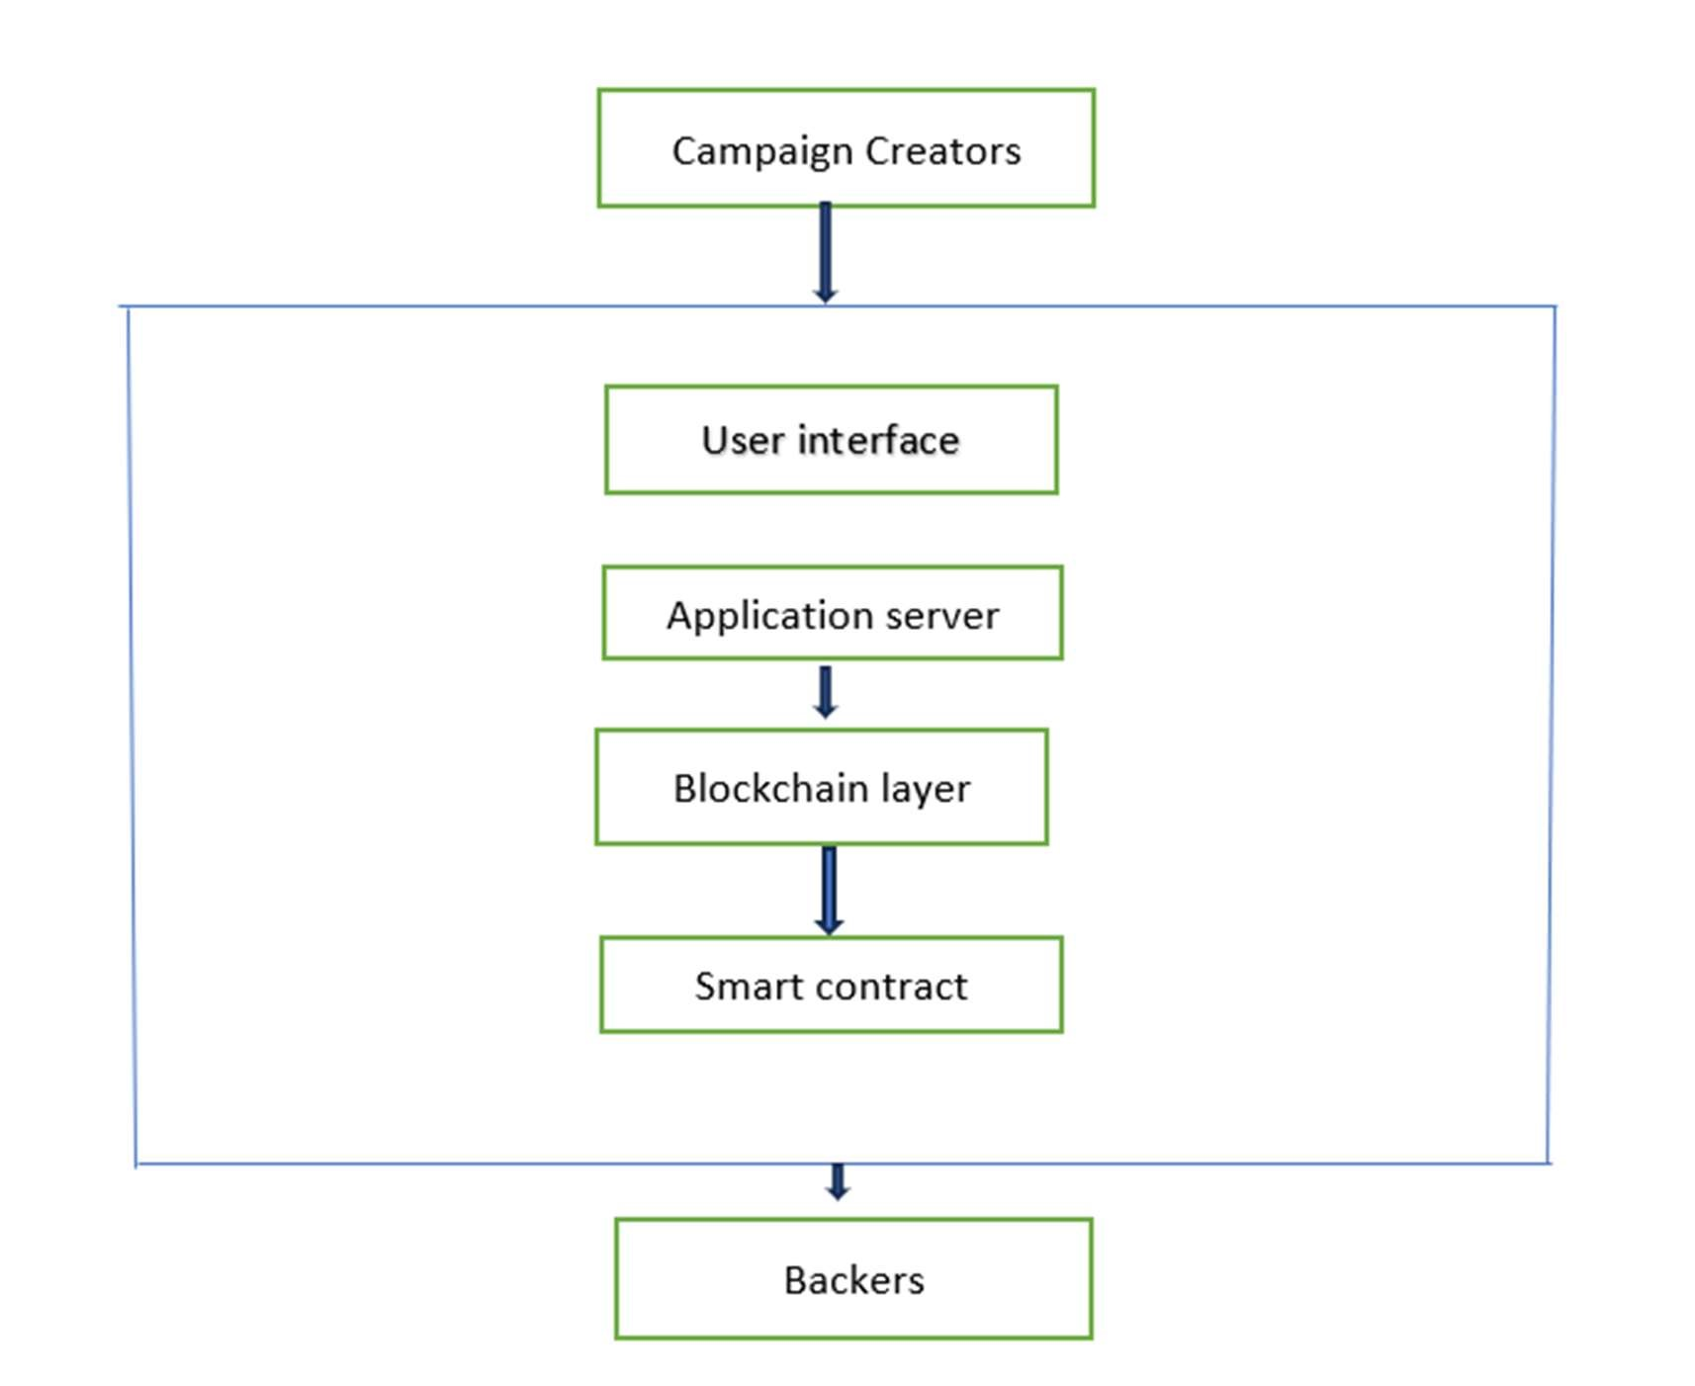

*Fig-4.2 context diagram*

*Campaign Creators engage with the User Interface to initiate and oversee campaigns, managing details such as funding goals and updates throughout the campaign lifecycle. Backers utilize the User Interface to explore available campaigns and make contributions based on their interests and preferences. The User Interface facilitates these interactions by transmitting user requests to the Application Server, which handles backend operations and interfaces with the Blockchain Layer. Here, transactions are managed securely via Smart Contracts, ensuring adherence to predefined rules and conditions. The Blockchain Layer plays a crucial role in guaranteeing the security, transparency, and immutability of all transactions, leveraging its decentralized nature for enhanced reliability. Real-time updates on campaign progress and contributions are facilitated by the Notification Service, keeping users informed promptly. Meanwhile, the Payment Gateway integrates seamlessly with cryptocurrency wallets, enabling backers to contribute using various cryptocurrencies like Bitcoin and Ethereum, thus promoting accessibility and flexibility within the platform.*

*This diagram illustrates the process flow of the blockchain-based crowdfunding platform and how different system components interact with each other, starting from campaign creators and ending with backers.*

*At the top level, campaign creators initiate crowdfunding campaigns by providing details such as project description, funding target, deadline, and media attachments. They interact with the system through the user interface, which acts as the front-end layer of the platform. This interface is designed to be simple, intuitive, and responsive, ensuring campaign creators can easily create and manage their projects without needing to understand the underlying blockchain complexities.*

*Once campaign details are submitted, the requests are processed by the application server, which acts as the middleware. The server validates input, communicates with the blockchain layer, and handles tasks like storing metadata, user authentication, and routing. It essentially bridges the gap between the user interface and the blockchain.*

*The blockchain layer is the core of the system, responsible for ensuring data integrity, transparency, and decentralization. When campaign creation or contributions occur, the blockchain layer ensures that these records are permanently stored on the distributed ledger. It eliminates any possibility of data manipulation, thereby guaranteeing trust and accountability.*

*Within the blockchain layer, smart contracts play a central role. These are self-executing contracts coded in Solidity, which enforce the predefined rules of the crowdfunding platform. Smart contracts automatically handle fund collection, disbursement upon milestone achievement, or refunds if the campaign fails. By automating these critical processes, the platform eliminates the need for intermediaries and ensures fairness for both campaign creators and backers.*

*Finally, backers interact with the system by browsing campaigns, contributing funds, and tracking project progress. Their contributions are recorded transparently via the blockchain and executed through smart contracts. Backers are assured that their funds are securely managed and released only under the conditions agreed upon at the time of contribution.*

***4.3 TEST CASES***

***1****.* ***Functional Test Cases***

|  |  |  |  |
| --- | --- | --- | --- |
| ***TC ID*** | *Description* | *Input* | *Expected Output* |
| *TC01* | *User Registration* | *Name, Email, Wallet Address* | *Account created* |
| *TC02* | *User Login* | *Email + Password* | *Dashboard opens* |
| *TC03* | *Create Campaign* | *Title, Goal, Deadline* | *Campaign created* |
| *TC04* | *Invest in Campaign* | *Campaign ID + Amount* | *Transaction successful* |
| *TC05* | *Withdraw Funds* | *Creator requests withdrawal* | *Funds transferred* |
| *TC06* | *Campaign Expiry* | *Deadline passed without goal* | *Campaign marked “Expired”* |

***2. Smart Contract Test Cases***

| ***TC ID*** | ***Description*** | ***Expected Output*** |
| --- | --- | --- |
| *SC01* | *Deploy Smart Contract* | *Contract deployed on blockchain* |
| *SC02* | *Automatic Refund* | *Investors refunded if goal not reached* |
| *SC03* | *Unauthorized Withdrawal* | *Transaction denied* |

***3. Non-Functional Test Cases***

|  |  |  |
| --- | --- | --- |
| ***TC ID*** | ***Description*** | ***Expected Output*** |
| *NTC01* | *Performance* | *System supports multiple campaigns at once* |
| *NTC02* | *Security* | *Unauthorized login/transactions blocked* |
| *NTC03* | *Transparency* | *Investors view real-time funding records* |

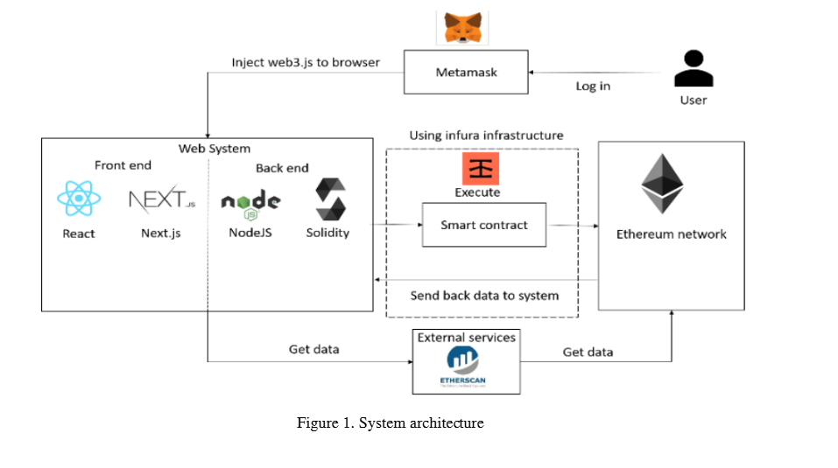***4.4 USE CASE DIAGRAM***

***Explanation of System Architecture***

1. ***User and MetaMask***
   * *The user interacts with the system through a web interface.*
   * *MetaMask acts as a digital wallet and authentication tool, allowing users to log in securely and interact with the Ethereum blockchain.*
   * *When the user logs in via MetaMask, it injects Web3.js into the browser, enabling communication between the web application and the Ethereum network.*
2. ***Web System (Frontend & Backend)***

* *Frontend (React + Next.js):*
  + - *Provides the user interface where campaigners create campaigns, contributors make donations, and project progress can be monitored.*
    - *React ensures a dynamic user experience, while Next.js helps with server-side rendering and routing.*
* *Backend (Node.js + Solidity):*
  + *Node.js handles application logic, API calls, and interaction with smart contracts.*
  + *Solidity is used to write smart contracts, which define rules for fund collection, milestone validation, and fund disbursement.*

1. ***Infra Infrastructure***

* *Acts as a bridge between the web system and the Ethereum network.*
* *Handles blockchain node communication without requiring the system to maintain its own full Ethereum node.*
* *Executes smart contracts and sends data back to the web system.*

1. ***Smart Contracts***

* *The core logic of the crowdfunding system resides here.*
* *Smart contracts automate:*
* *Fund collection from contributors.*
* *Conditional release of funds to campaigners when milestones are met.*
* *Refunds in case of project failure.*

1. ***Since smart contracts are immutable, they ensure transparency and prevent fund mismanagement.***

* *Ethereum Network*
* *A decentralized blockchain network where all transactions are recorded permanently.*
* *Provides immutability, transparency, and security.*

1. ***External Services (Etherscan)***

* *Etherscan is a blockchain explorer that retrieves and verifies on-chain data.*
* *Users can check transaction details, smart contract execution, and fund flow, ensuring transparency.*

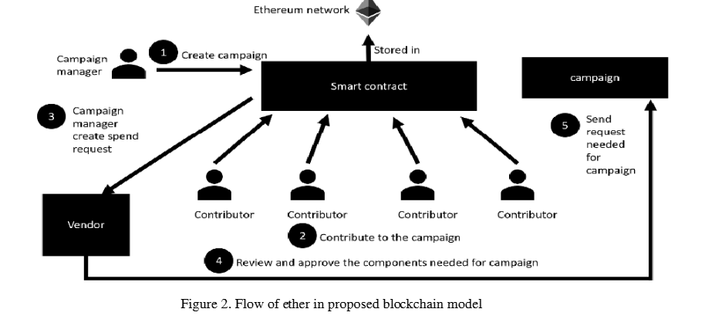

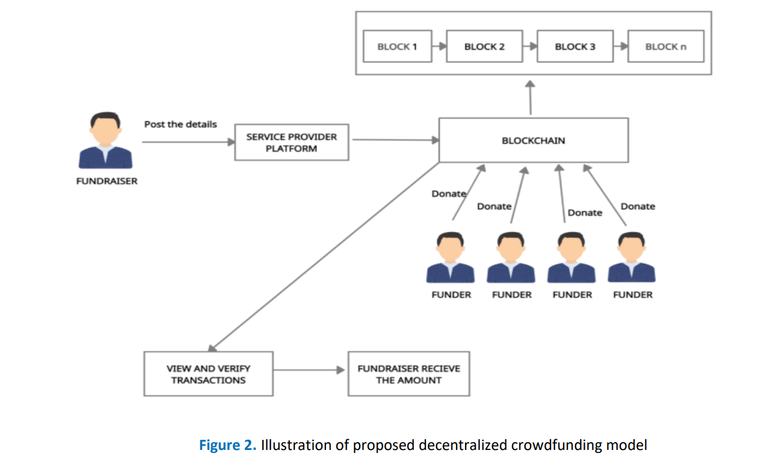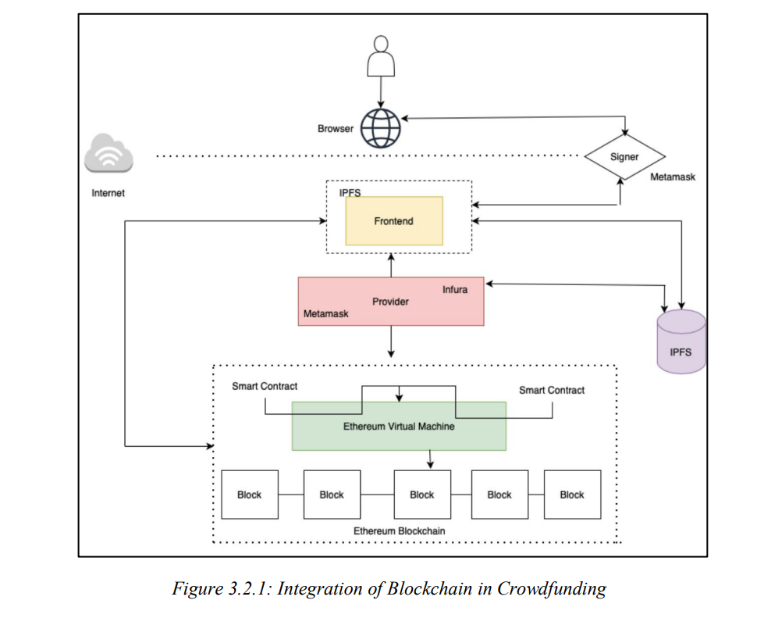

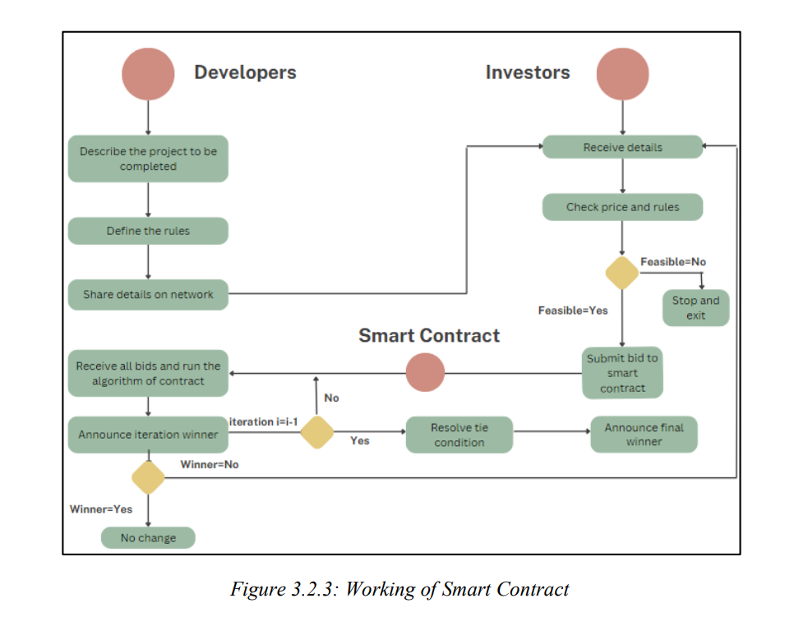

# ***Chapter 5 IMPLEMENTATION (CODE SNIPPETS)***

## *Code: Crowdfunding.sol*

*// SPDX-License-Identifier: UNLICENSED pragma solidity ^0.8.9;*

*contract CrowdFunding { struct Campaign { address owner; string title; string description; uint256 target; uint256 deadline; uint256 amountCollected; string image; address [] donators; uint256[] donations;*

*}*

*mapping (uint256 => Campaign) public campaigns;*

*uint256 public numberOfCampaigns = 0;*

*function createCampaign (address _owner, string memory _title, string memory _description, uint256 _target, uint256 _deadline, string memory _image) public returns*

*(uint256) {*

*Campaign storage campaign = campaigns[numberOfCampaigns];*

*require (campaign. deadline < block. timestamp, "The deadline should be a date in the future.");*

*campaign.owner = _owner; campaign.title = _title; campaign.description = _description; campaign.target = _target; campaign.deadline = _deadline; campaign.amountCollected = 0; campaign.image = _image; numberOfCampaigns++; return numberOfCampaigns - 1;*

*}*

*function donateToCampaign(uint256 _id) public payable { uint256 amount = msg.value;*

*Campaign storage campaign = campaigns[_id]; campaign.donators.push(msg.sender); campaign.donations.push(amount);*

*(bool sent,) = payable(campaign.owner).call{value: amount}(""); if(sent) {*

*campaign.amountCollected = campaign.amountCollected + amount;*

*}*

*}*

*function getDonators(uint256 _id) view public returns (address[] memory, uint256[] memory) {*

*return (campaigns[_id].donators, campaigns[_id].donations);*

*}*

*function getCampaigns() public view returns (Campaign[] memory) {*

*Campaign[] memory all Campaigns = new Campaign[](numberOfCampaigns);*

*for(uint i = 0; i < numberOfCampaigns; i++) {*

*Campaign storage item = campaigns[i];*

*allCampaigns[i] = item;*

*}*

*return allCampaigns;*

*}*

*}*

*App.jsx:*

*import React from 'react';*

*import { Route, Routes } from 'react-router-dom';*

*import { Sidebar, Navbar } from './components';*

*import { CampaignDetails, CreateCampaign, Home, Profile } from './pages';*

*const App = () => { return (*

*<div className="relative sm:-8 p-4 bg-black min-h-screen flex flex-row">*

*<div className="sm:flex hidden mr-10 relative">*

*<Sidebar />*

*</div>*

*<div className="flex-1 max-sm:w-full max-w-[1280px] mx-auto sm:pr-5"> <Navbar />*

*<Routes>*

*<Route path="/" element={<Home />} />*

*<Route path="/profile" element={<Profile />} />*

*<Route path="/create-campaign" element={<CreateCampaign />} />*

*<Route path="/campaign-details/:id" element={<CampaignDetails />} />*

*</Routes>*

*</div>*

*</div>*

*)*

*} export default App*

***5.1 Screenshots:***

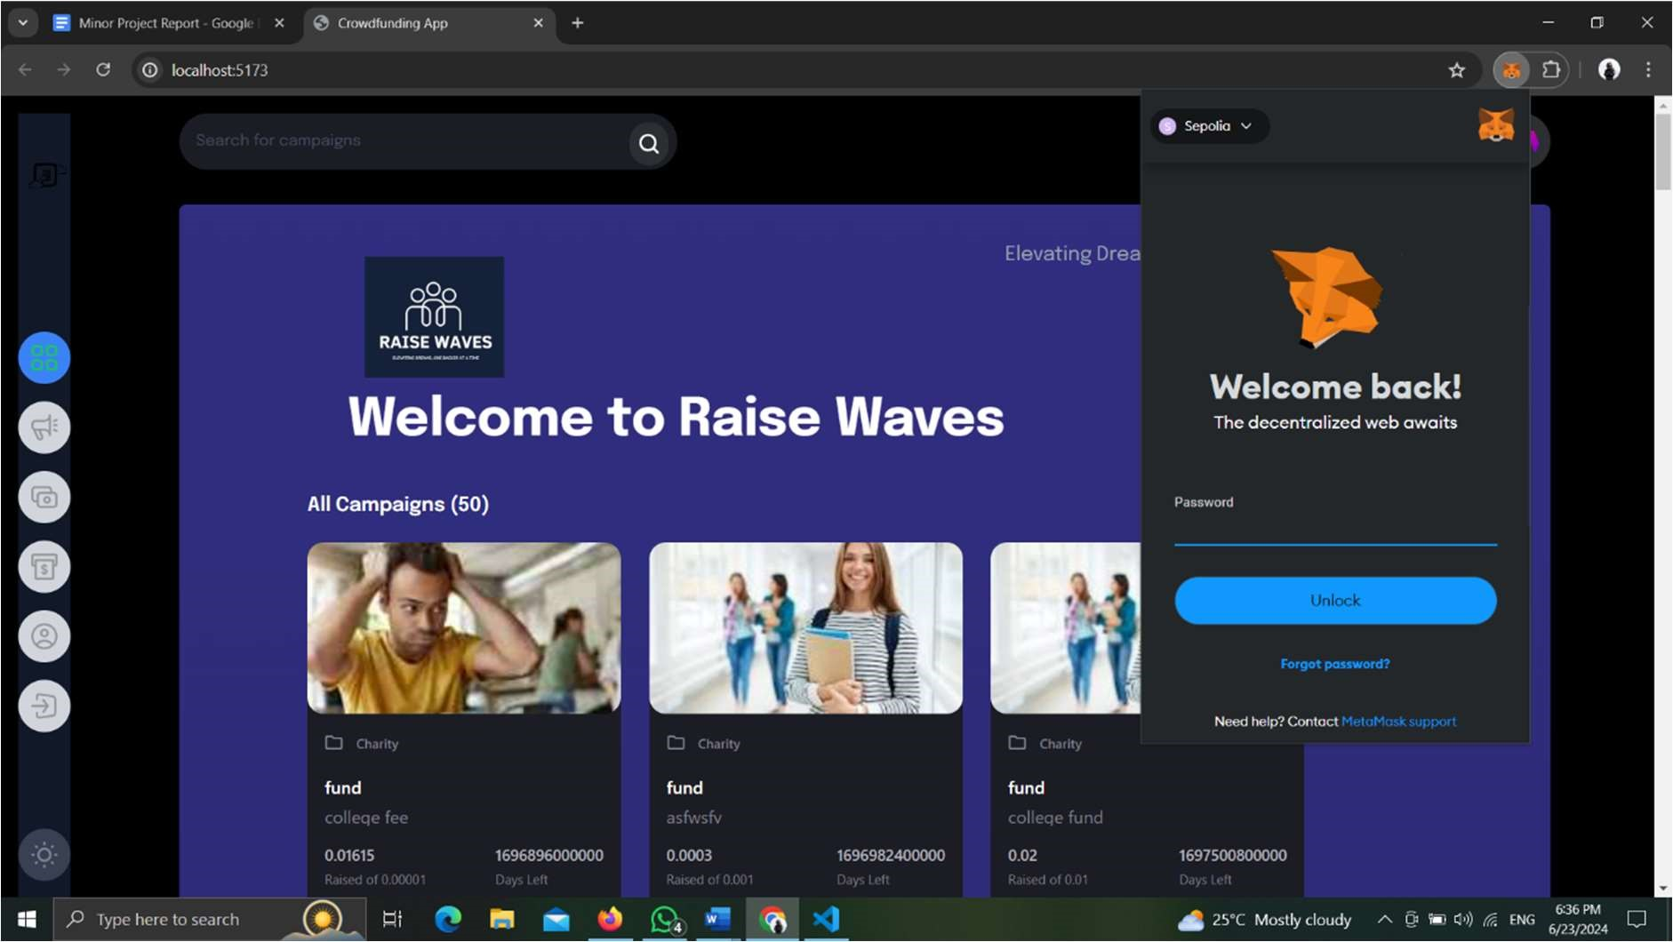

***Fig-5.1.1 MetaMask connection***

*In the above fig-5.1.1 we are connection crypto wallet i.e. MetaMask to our website where user can contribute to the ongoing crowdfunding campaign*

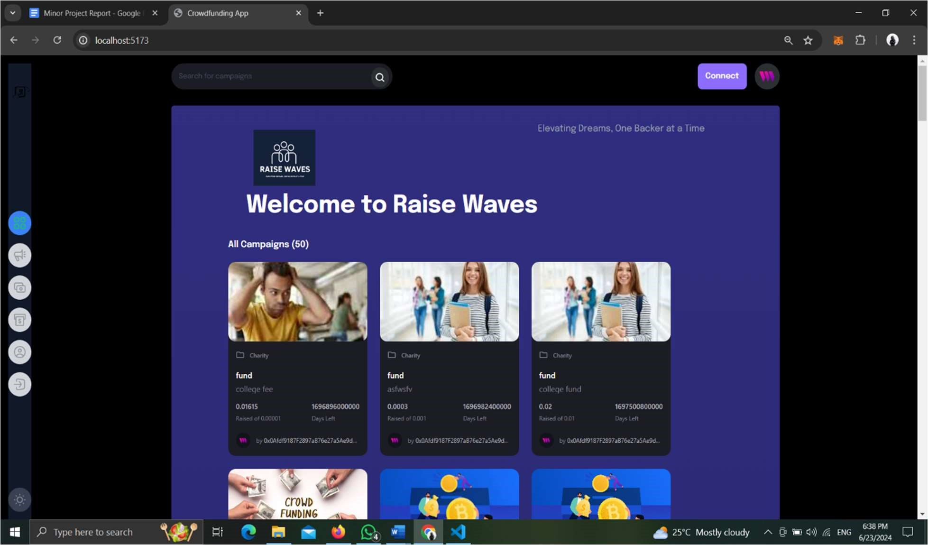

***Fig-5.1.2 Dashboard***

*The above fig-5.1.2 is the home page or dashboard where we are going to get all the campaign which can later use by the user to contribute to the crowdfunding campaign.*

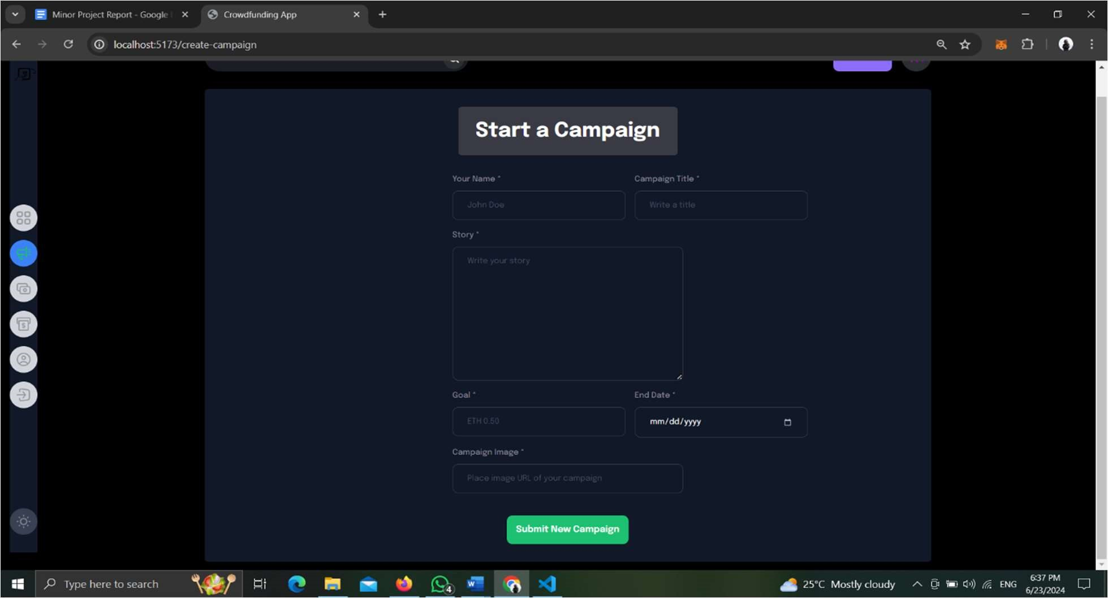

***Fig-5.1.3 Create campaign page***

*In the above fig-5.1.3 the user can create a campaign by giving his name, title, story of the campaign for what he is collecting funds, end date of the campaign, goal of the campaign and image URL for displaying it on the dashboard.*

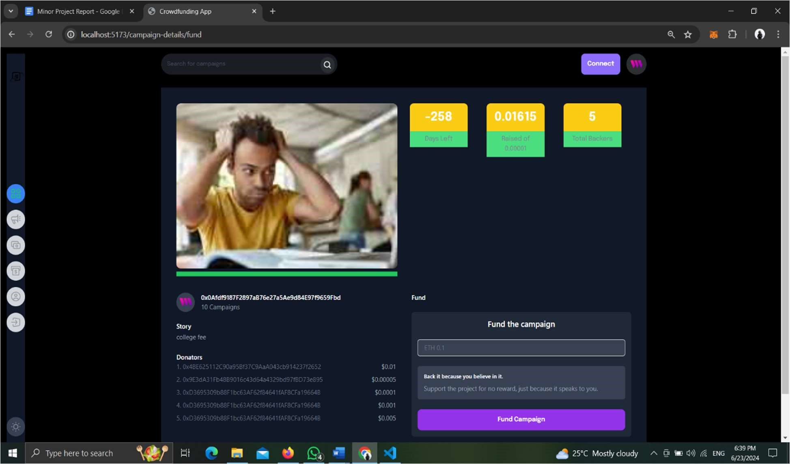

***Fig-5.1.4 Campaign Page***

*The above fig-5.1.4 is the campaign page where user can contribute to the specific campaign by selecting the particular campaign. After selecting the specific campaign this page appears where user get information of total number of people contributed and total amount that is been raised.*

***6. CONCLUSION***

*Conventional crowdfunding methods have often struggled with issues such as lack of transparency, misuse of funds, and the possibility of fraudulent activities. These drawbacks limit the confidence of potential investors and affect the credibility of campaigns. This project has aimed to address these challenges by leveraging the strengths of blockchain technology, which inherently provides immutability, transparency, and decentralization.*

*The proposed blockchain-based crowdfunding platform integrates smart contracts to automate processes such as campaign creation, fund collection, withdrawal, and refund. This automation not only eliminates the role of intermediaries but also ensures that predefined rules are strictly enforced. As a result, trust is established between campaign creators and contributors without the need for third-party oversight.*

*By implementing decentralized ledger technology, all transactions are securely recorded and made visible to every participant in the network. This ensures transparency and accountability at every stage of the crowdfunding process. Donors and investors can track the flow of funds in real time, thereby reducing the fear of fraud and misuse. The system also ensures fairness, as campaign creators can withdraw funds only after successfully meeting their funding goals, while investors are automatically refunded if the campaign fails.*

*The objectives of building a transparent, secure, and anti-fraudulent crowdfunding platform have been achieved to a considerable extent in this project. It successfully demonstrates how blockchain can transform traditional fundraising models by offering reliability, efficiency, and trust. In doing so, the platform strengthens the bond between creators and contributors and promotes a healthier, more sustainable crowdfunding ecosystem.*

*Overall, this work highlights the potential of blockchain technology to reshape the future of digital fundraising. By addressing the inherent weaknesses of conventional platforms, it paves the way for more trustworthy, decentralized, and globally accessible crowdfunding solutions.*

# ***7. FUTURE ENHANCEMENT***

* ***Integration of Additional Blockchains:*** *The integration of additional blockchains such as Binance Smart Chain, Polkadot, and Solana broadens the platform's transaction choices. This enables customers to benefit from potentially lower fees and more interoperability. The upgrade seeks to provide a more versatile and user-friendly platform, catering to various blockchain tastes and requirements.*
* ***Enhanced User Experience (UX):*** *By taking user response into account and implementing the newest design trends, enhanced user experience refers to the ongoing improvement of the user interface and overall user experience. By enhancing user engagement and satisfaction, this strategy hopes to boost conversion rates and platform utilization. The platform becomes more intuitive and appealing by emphasizing user centric design and usability, which encourages more frequent and sustained user interactions.*
* ***AI and Machine Learning Integration:*** *Predictive analytics, personalized advertising recommendations, and fraud detection are just a few of the jobs that will be handled by AI and machine learning. By spotting and stopping questionable activity, this integration improves security and makes the user experience safer. Furthermore, it enhances the user experience by providing personalized insights and information, which makes the platform more interesting and pertinent to each user's requirements and tastes.*
* ***Mobile Application Development:*** *In order to enhance the current web platform, mobile development will concentrate on producing native applications for both iOS and Android. By enabling users to manage their campaigns and contributions from anywhere at any time, this method improves accessibility and convenience. The platform becomes more adaptable and user-friendly by providing a mobile-friendly experience, satisfying the increasing need for mobile device usage.*
* ***Crowdfunding Campaign Analytics:*** *Providing comprehensive analytics and reporting tools to campaign creators is a key component of crowdfunding campaign analytics. With the aid of these technologies, designers will be able to monitor the success of their campaigns and adjust their tactics in light of new information. Campaign designers can increase their chances of success by using data to inform their decisions. This is because they will be better able to determine what aspects of their campaigns are effective and which ones require modification.*

# ***8. BIBOLOGRAPHY***

* *S. Venslavien, J. Stankeviciene, and I. Lescauskiene, "Evaluation of Blockchain-Based Crowdfunding Drive Success Factors Based on VASMA-L Criteria Weighting Method," in Proceedings of the International Conference on Business and Management, vol. 1, no. 1, pp. 123-130, June 2023.*
* *M. N. Saadat, S. A. Halim, H. Osman, R. M. Nassr, and M. F. Zuhairi, "Blockchain based crowdfunding systems," *Indonesian J. Electr. Eng. Comput. Sci.*, vol. 15, no. 1, pp. 409– 413, Jul. 2019, doi: 10.11591/ijeecs.v15.i1.pp409-413.*
* *A. D. Choudary, "Role of blockchain technology in crowdfunding," in *Proc. 4th Int. Conf. on Manag., Econ. Finance*, Hyderabad, India, 10–12 Sep. 2021.*
* *A. Varghese, N. A. Regi, S. Babu, S. Mani, and C. M. Varghese, "Crowdfunding platform using blockchain," *Int. Res. J. Mod. Eng. Technol. Sci.*, vol. 5, no. 5, pp. 57-79, May 2023. e-ISSN: 2582-5208.*
* *F. Ashari, T. Catonsukmoro, W. M. Bad, S. Sfenranto, and G. Wang, "Smart contract and blockchain for crowdfunding platform," *Int. J. Adv. Trends Comput. Sci. Eng.*, vol. 9, no. 3, pp. 123-129, May–Jun. 2020. doi: 10.30534/ijatcse/2020/83932020.*
* *S. Phatangare, S. Patil, S. Patil, Y. Patil, and P. Churi, "Blockchain based crowdfunding platform using Ethereum," *Int. J. Creative Res. Thoughts (IJCRT)*, vol. 11, no. 5, pp. 20-25, May 2023. ISSN: 2320-2882.*
* *A. K. Singh, P. Srivastava, A. Jaiswal, and P. SM, "A Survey on Crowdfunding Using Blockchain Technology," International Journal of Creative Research Thoughts (IJCRT), vol. 12, no. 1, pp. b51-b57, Jan. 2024, ISSN: 2320-2882.*
* *F. Fernandes, H. Gharat, A. Kadam, and A. Kamil, "Crowd Funding Platform Using Blockchain," International Journal of Innovative Research in Technology (IJIRT), vol. 9, no. 10, pp. 112-116, Mar. 2023, ISSN: 2349-6002.*
* *R. Sulekh, M. Katiyar, and D. Trivedi, "Crowdfunding Platform using Smart Contracts," International Journal of Innovative Science and Research Technology (IJISRT), vol. 8, no. 6, pp. 709-714, June 2023, ISSN: 2456-2165.*
* *D. L. Falak, S. Shanawaz, P. Jadhav, K. Kajal, and U. Shukla, "Crowd-Funding Using Blockchain Technology," International Journal of Research Publication and Reviews, vol. 3, no. 11, pp. 2214-2216, Nov. 2022, ISSN: 2582-7421.*
* *A. Chattani, A. Sharma, and A. Manhar, "Research Paper on 'Crowdfunding using*

*Blockchain'," Journal of Emerging Technologies and Innovative Research (JETIR), vol. 10, no. 6, pp. g518-g522, June 2023, ISSN: 2349-5162.*

* *S. Varshney, S. Aggarwal, V. Sharma, and R. Sharma, "Crowd Gain – Crowdfunding Web Application Based on Blockchain using Ethereum," International Journal of Advanced Research in Science, Communication and Technology (IJARSCT), vol. 3, no. 6, pp. 71-75, May 2023,, ISSN: 2581-9429.*
* *S. Zad, Z. Khan, T. Warambhe, R. Jadhav, and V. Alone, "Crowdfunding using Blockchain Technology", Department of Computer Engineering, University of Mumbai, VPPCOE, Sion-Chunabhatti, Mumbai-400022, India, 2023.*
* *B. Tiganoaia and G.-M. Alexandru, "Building a Blockchain-Based Decentralized Crowdfunding Platform for Social and Educational Causes in the Context of Sustainable Development," Sustainability, vol. 15, no. 23, p. 16-205, Nov. 2023.*
* *M. W. K. M. Mithsara and T. M. K. K. Jinasena, "Blockchain-based distributed secure crowdfunding and decision-making platform for large-scale business projects in public and private sectors," *Eur. Mod. Stud. J.*, vol. 4, no. 5, pp. 72-76, 2020.*

***9.******Appendices***

*The implementation of the blockchain-based crowdfunding platform was carried out using Solidity for smart contracts and React with Node.js for the web interface. Only the most important code blocks are included here to highlight the functioning of the system, rather than the entire source code.*

*The smart contract (Crowdfunding.sol) is the backbone of the system. It defines the structure of a campaign, including essential fields such as the campaign owner, title, description, funding goal, deadline, amount collected, and the list of donators with their contributions. The contract provides key functionalities like campaign creation, donation handling, and retrieval of donor details. For instance, the createCampaign function ensures that only campaigns with valid deadlines are registered, while the donateToCampaign function allows contributors to send Ether directly to the campaign owner, updating records of contributors and amounts. This ensures that all financial transactions are securely handled by the blockchain, eliminating the need for intermediaries.*

*On the frontend side, the application was implemented using React and React Router for navigation. The routing structure is shown in the App.jsx file, where different pages such as Home, Profile, Create Campaign, and Campaign Details are mapped to specific routes. This allows users to browse campaigns, create new campaigns, view detailed campaign progress, and check their personal profile of contributions. Together, these code snippets illustrate how the frontend communicates with the backend smart contract to provide a seamless user experience.*

***Smart Contract (Crowdfunding.sol):***

*pragma solidity ^0.8.9;*

*contract CrowdFunding {*

*struct Campaign {*

*address owner;*

*string title;*

*string description;*

*uint256 target;*

*uint256 deadline;*

*uint256 amountCollected;*

*address[] donators;*

*uint256[] donations;*

*}*

*mapping (uint256 => Campaign) public campaigns;*

*uint256 public numberOfCampaigns = 0;*

*function createCampaign(*

*address _owner, string memory _title, string memory _description,*

*uint256 _target, uint256 _deadline*

*) public returns (uint256) {*

*Campaign storage campaign = campaigns[numberOfCampaigns];*

*require(_deadline > block.timestamp, "Deadline must be in the future");*

*campaign.owner = _owner;*

*campaign.title = _title;*

*campaign.description = _description;*

*campaign.target = _target;*

*campaign.deadline = _deadline;*

*numberOfCampaigns++;*

*return numberOfCampaigns - 1;*

*}*

*function donateToCampaign(uint256 _id) public payable {*

*Campaign storage campaign = campaigns[_id];*

*campaign.donators.push(msg.sender);*

*campaign.donations.push(msg.value);*

*(bool sent,) = payable(campaign.owner).call{value: msg.value}("");*

*require(sent, "Donation failed");*

*campaign.amountCollected += msg.value;*

*}*

*}*

***Frontend Integration (App.jsx – Routing Example):***

*import { Route, Routes } from 'react-router-dom';*

*import { Home, Profile, CreateCampaign, CampaignDetails } from './pages';*

*const App = () => (*

*<Routes>*

*<Route path="/" element={<Home />} />*

*<Route path="/profile" element={<Profile />} />*

*<Route path="/create-campaign" element={<CreateCampaign />} />*

*<Route path="/campaign-details/:id" element={<CampaignDetails />} />*

*</Routes>*

*);*

*export default App;*

***B. User Manual / Installation Guide***

*The developed system is designed to be simple to install and user-friendly to operate. Users must first ensure they have the necessary requirements: Node.js (version 16 or higher) installed on their system, the MetaMask browser extension configured, and access to an Ethereum test network such as Goerli or Polygon Mumbai.*

*To install the project, users begin by cloning the source code repository and navigating to the project directory. Once inside the directory, they install all required dependencies using npm install. The next step involves deploying the smart contract (Crowdfunding.sol) on a test network using either Remix IDE or Hardhat. Once deployed, the contract address is retrieved and updated in the configuration file of the frontend application to enable communication between the frontend and the blockchain.*

*After configuration, the frontend can be launched with the command npm start, which starts the development server and makes the application accessible at http://localhost:3000. Upon opening the web application, users are prompted to connect their MetaMask wallet. Once connected, campaign creators can launch new campaigns by providing details such as campaign title, description, funding goal, deadline, and optional image. Backers, on the other hand, can browse available campaigns, view their details, and contribute funds directly from their connected wallet.*

*This installation and usage process ensures that both technical and non-technical users can engage with the platform easily, with the complexity of blockchain transactions abstracted behind a simple and intuitive interface.*

***System Requirements:***

* *Node.js (v16 or above)*
* *MetaMask browser extension*
* *Internet connection*
* *Ethereum test network (Goerli/Polygon Mumbai)*

***Installation Steps:***

1. ***Clone the repository:***

*git clone <repository-link>*

*cd crowdfunding-dapp*

1. ***Install dependencies:***

*npm install*

1. ***Compile and deploy smart contract:***

* *Use Hardhat/Remix IDE to deploy Crowdfunding.sol on the testnet.*
* *Copy the deployed contract address.*

1. ***Configure frontend:***

*Update contract ABI and address in config.js.*

1. ***Start frontend application:***

*npm start*

1. ***Open the application in browser:***

[*http://localhost:3000*](http://localhost:3000)

1. ***Connect MetaMask wallet and begin creating or funding campaigns.***

***C. Dataset Details***

*This project does not use an external dataset. Instead, it generates and stores campaign-related data on the blockchain. The key data points include:*

* *Campaign Information: Title, description, funding goal, deadline, creator wallet address.*
* *Contribution Data: Contributor addresses, contribution amounts, transaction history.*
* *Smart Contract Records: Immutable logs of all campaigns and donations.*